**Python FSD**

Capstone Project Solution

Online Banking Application – Phase 1



**Online Banking Application**

**Steps to be followed:**

1. Installing dependencies required for the project
2. Starting the MongoDB server and creating bankdb schema in MongoDB
3. Setting Python project
   1. Creating a workspace for VS Code
   2. Creating Virtual Environment
   3. Installing dependencies
   4. Creating a project in VS Code
   5. Creating an app within project
   6. Updating respective files for code
4. Executing the projects and testing in POSTMAN

**Step 1: Installing dependencies required for the project**

1. Please ensure that the following tools are installed in your system:

* Python 3.x
* Visual Studio Code
* Django
* Django_rest_framework
* Djongo
* pymongo
* MongoDB
* Postman Client

1. Download the following GitHub repository:

https://github.com/Kaleakash/online-baking-application-using-react-python-django.git

**Step 2: Starting the MongoDB server and creating the bankdb schema in virtual lab**

* 1. Login the virtual lab with your login details.

Here I am python lab.

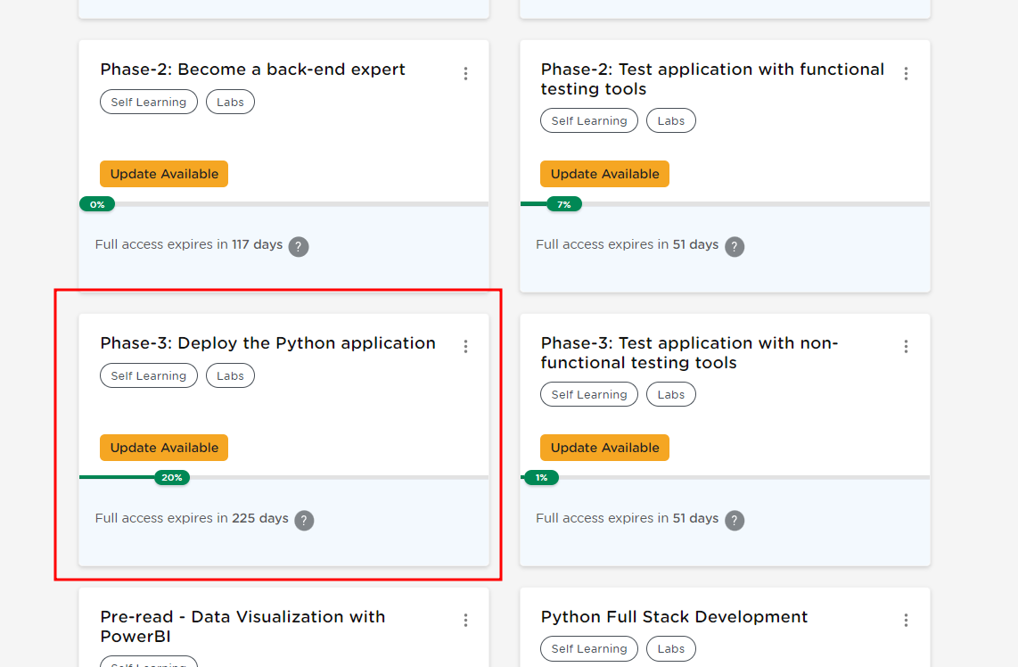

* 1. Open the terminal, and run the following command to check the MySQL server’s status:

**mongod --version**

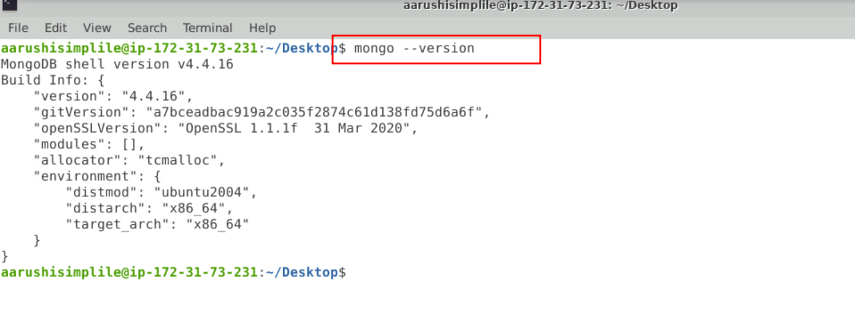

* 1. Run the following command to start the MongoDB server from the terminal

**sudo mkdir -p /data/db  
sudo mongod**

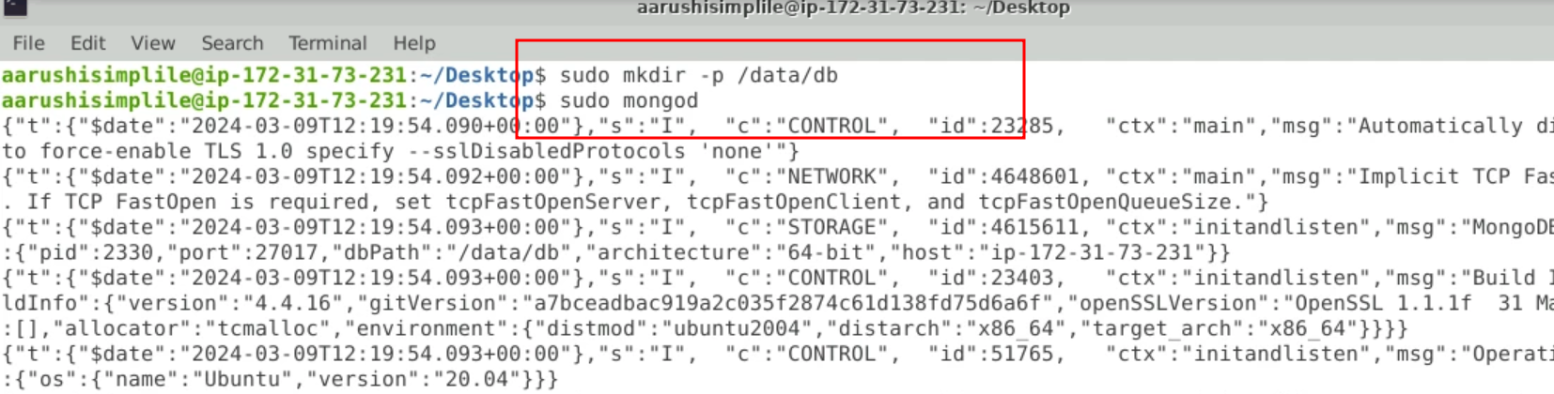

**If you are getting any error**

**Please remove the previous db file using below command**

**sudo rm -r /data/db**

NOTE: Do not close this terminal as this is the mongo server running.

In case getting /data/db error please execute the below command:

**sudo mkdir -p /data/db**

* 1. Open another terminal and use the following command to start the mongo shell:

**sudo mongo**

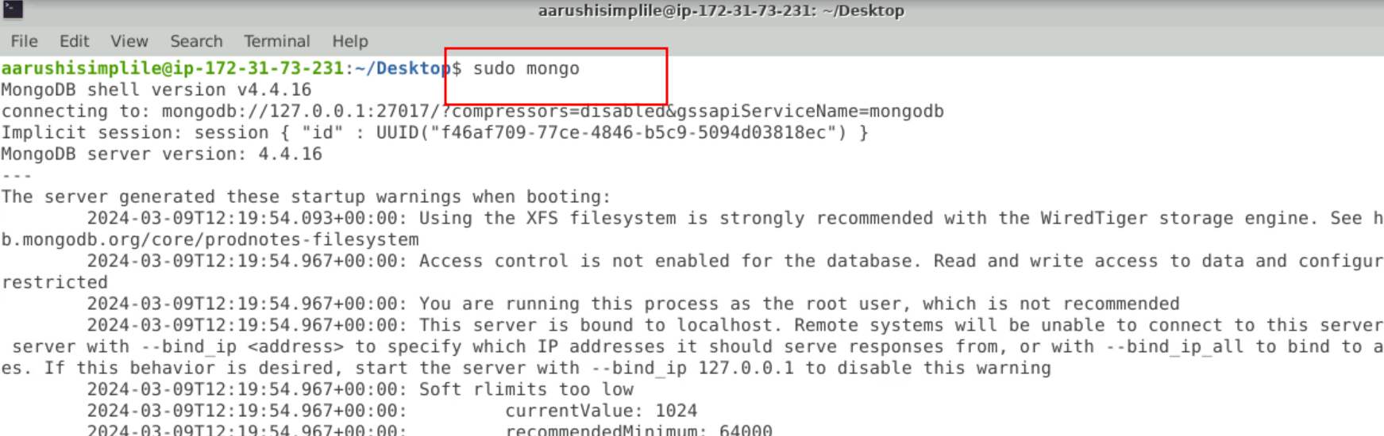

* 1. Once the mongo shell is up and running, run the below command to see existing databases:

**show dbs**

To create a database, execute the below command:

**use bankdb**

To see existing collections if any, execute the below command. It will be empty.

**show collections**

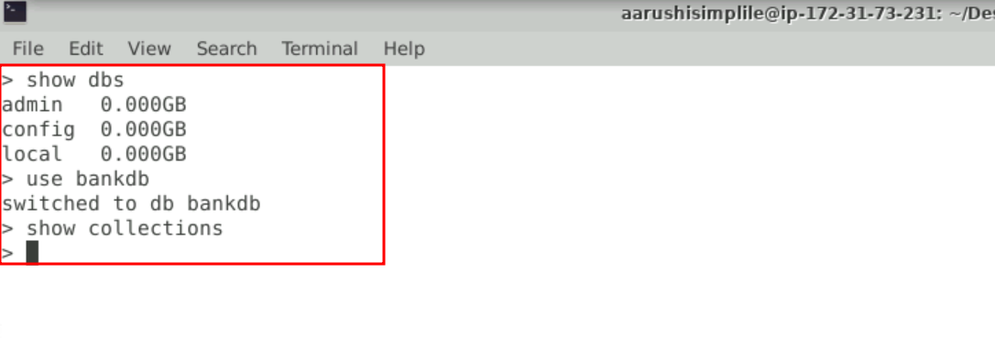

**Step 3: Now we create the environment for python to run the project.**

1. Create the folder as

**mkdir phase1-python-django-app**

1. Now we move inside this folder

**cd phase1-python-django-app/**

1. Now we need to create python virtual environment and active the virtual environment

**python3 -m venv .venv**

**source .venv/bin/activate**

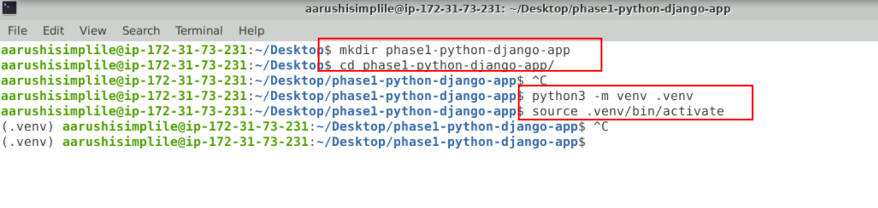

1. Open the VS code using the **code .**
2. Create the requirements.txt file which is responsible to install the require dependencies to run the application.

requirements.txt

Django == 3.0.6

djangorestframework==3.12.4

Markdown==3.3.6

django-filter==21.1

djongo

pymongo==3.12.3

sqlparse==0.2.4

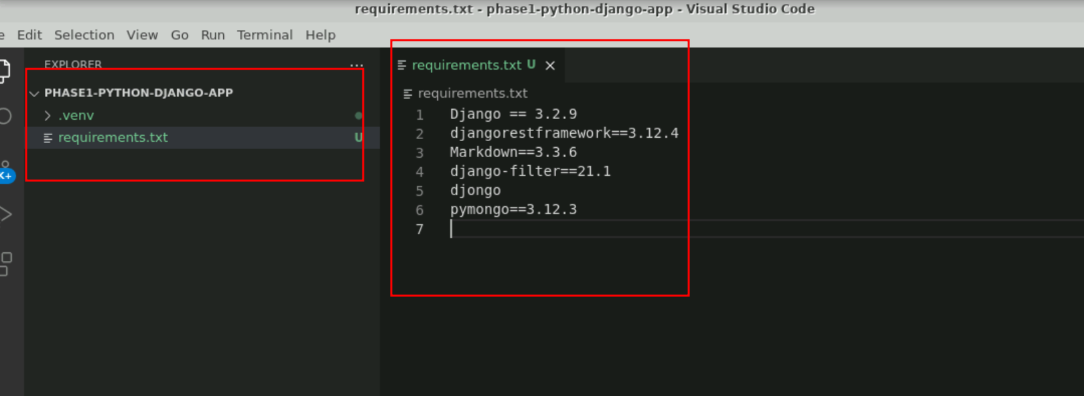

pip install -r requirements.txt

this command installs all required dependencies

**Step 3: Now we need to create the project**

* 1. Check the django-admin version as follows:  
     **django-admin version**

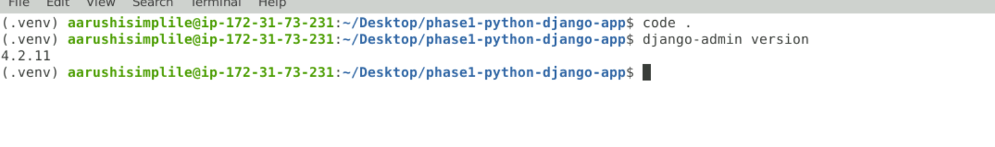

* 1. Create a Django project by executing the below command:  
     **django-admin startproject phase1bankingapp**



* 1. Execute the project by entering the phase1bankingapp folder and executing the commands below. The server should be up and running and the project available at **localhost:8000** as follows:

python manage.py runserver

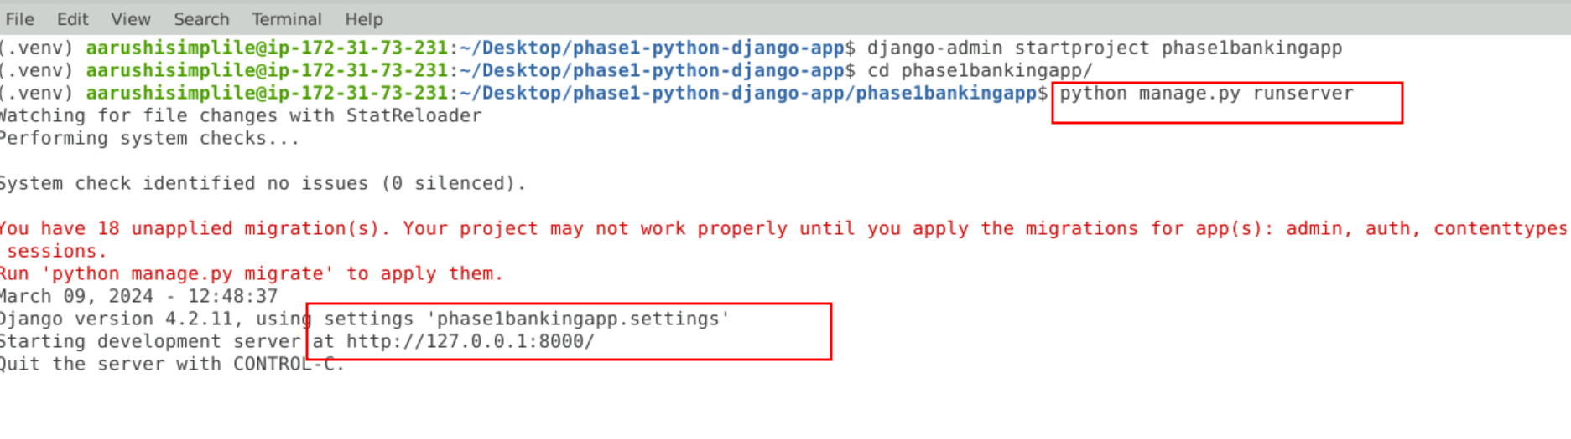  
  
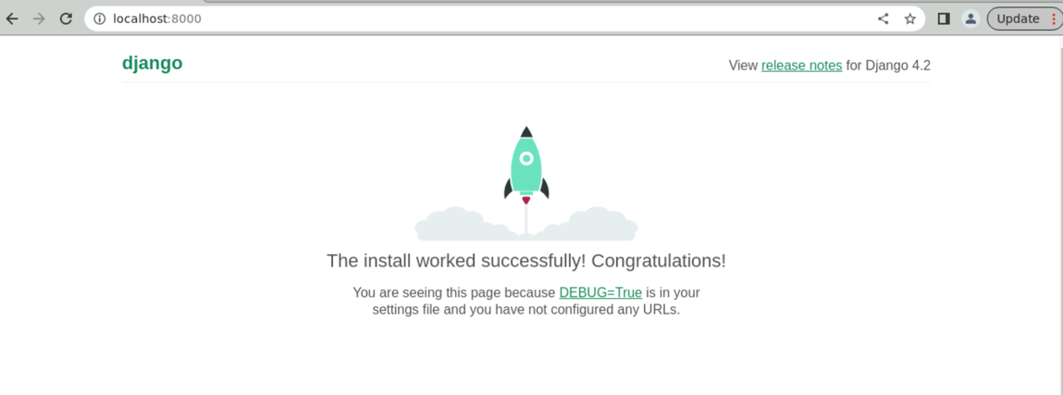

* 1. Now Hit Cntr + C to terminate the application
  2. Now we will create the app inside the project as It will create an app within the package explorer:  
     **django-admin startapp api**

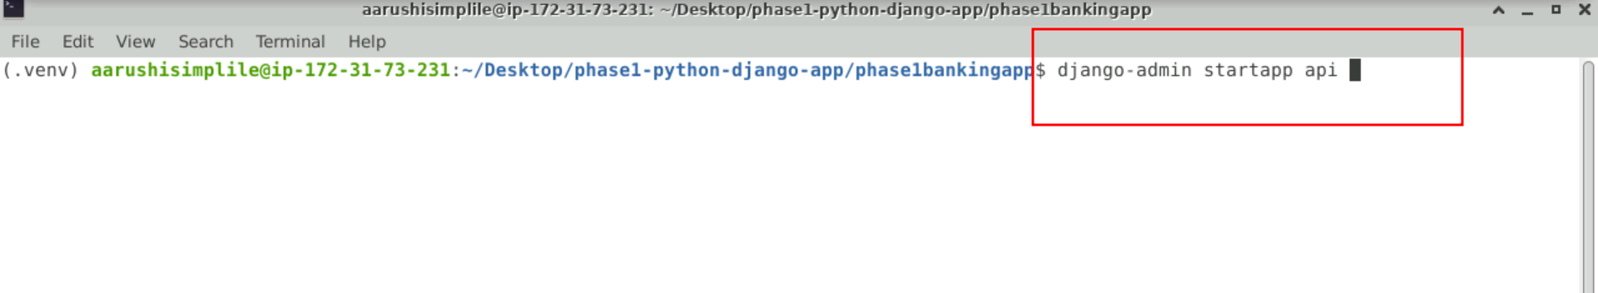

3.6 view the project structure in VS code.

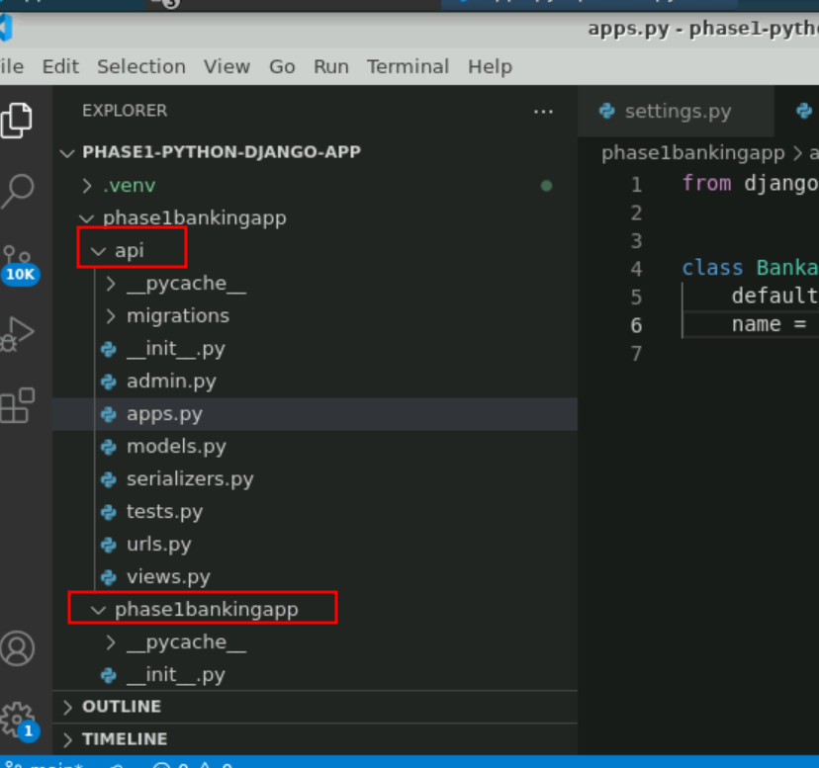

* 1. Make changes in the settings.py files for database configuration, adding apps and the authentication framework as follows:  
     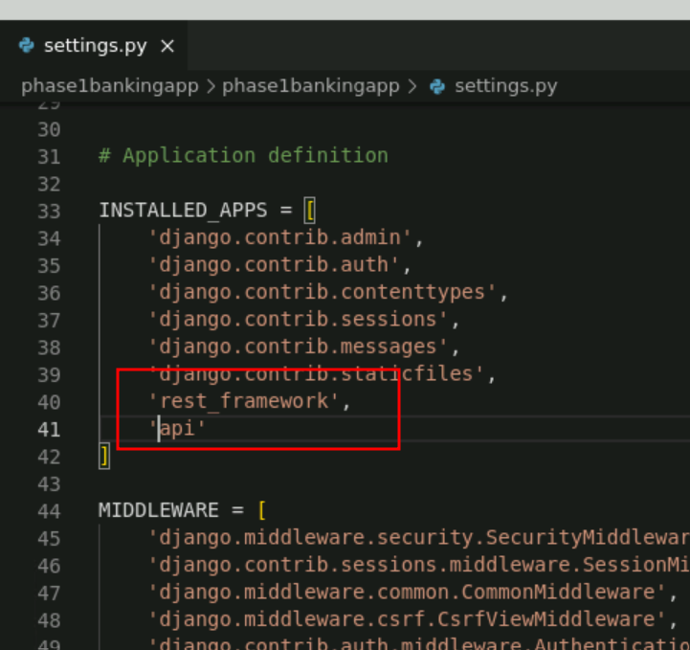
  2. By default Django use SQLite Database. But for our project we are using mogno db database so we need to do changes in database.

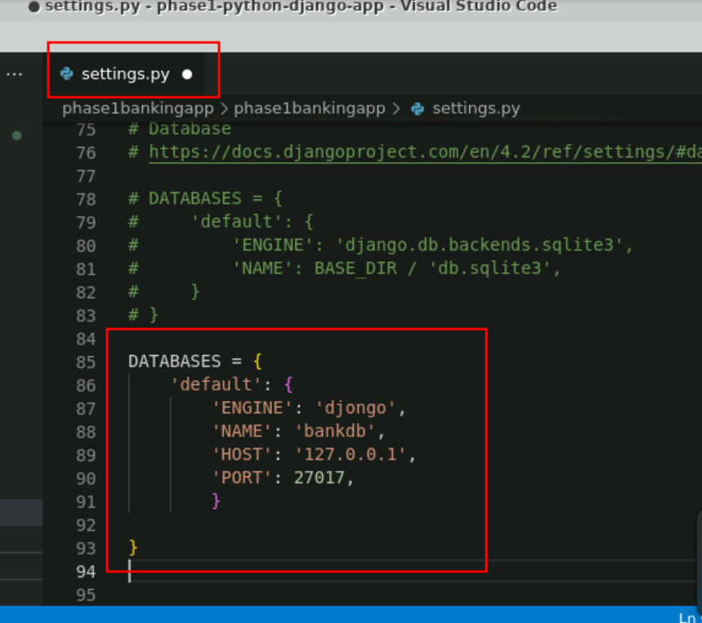

* 1. Create urls.py and serializers.py files within the bankapi folder as follows:

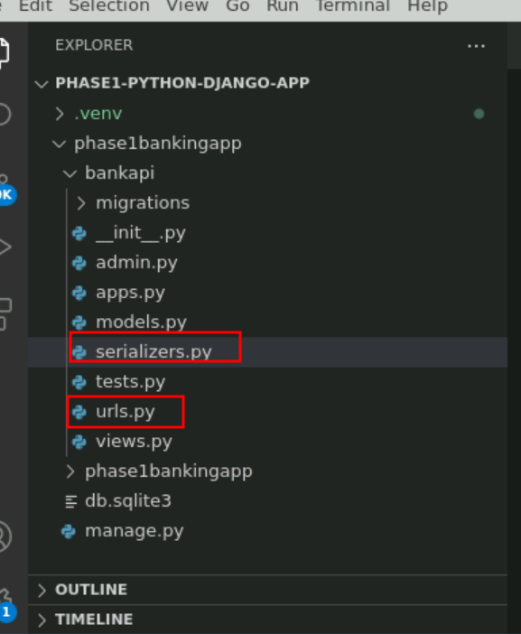

* 1. Update **models.py, urls.py, serializer.py, admin.py,vews.py** in bankapi app for your project

(Refer to GitHub repo for code)

**views.py file**

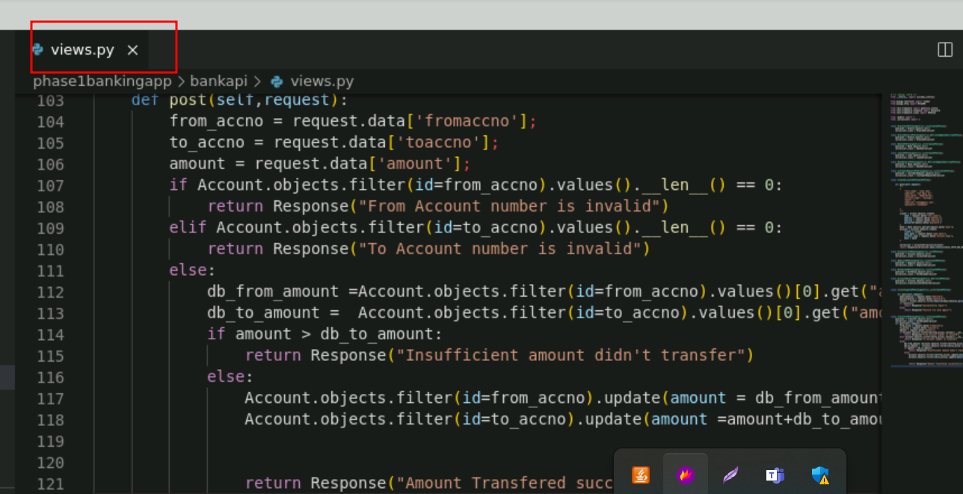

**urls.py**

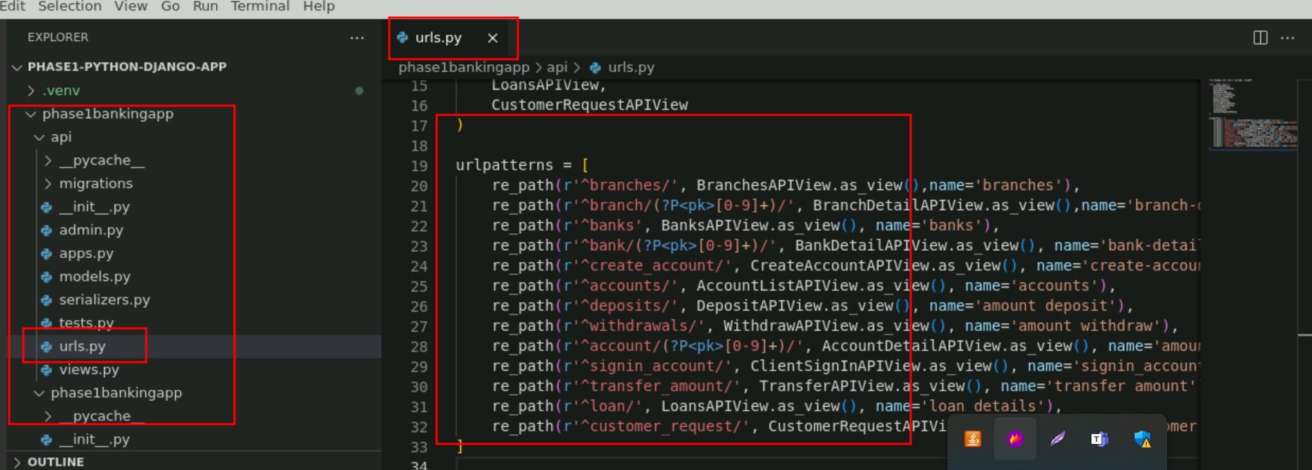

**serializer.py file**

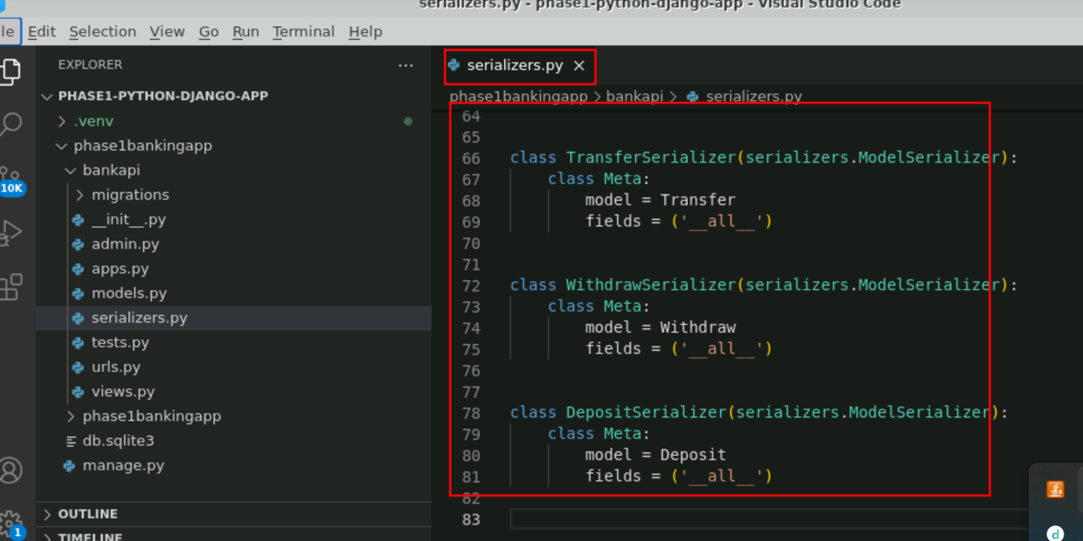

**models.py**

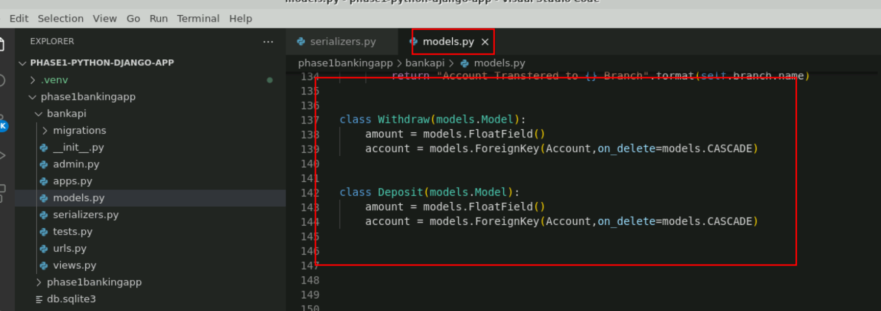

**admin.py**

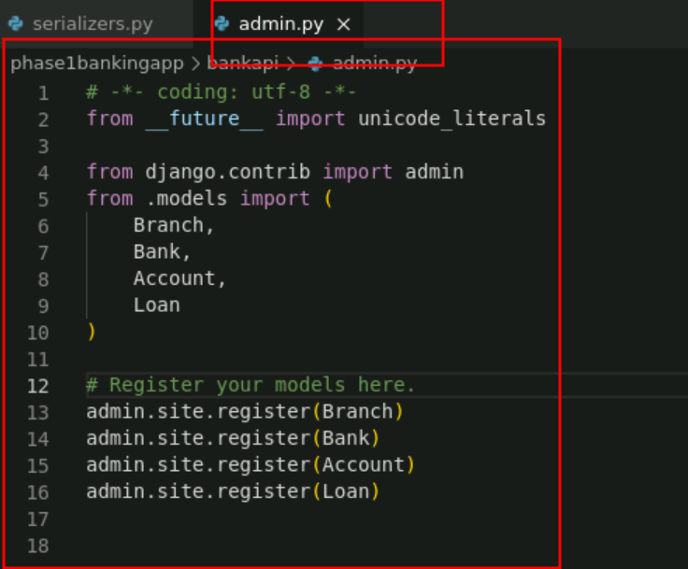

* 1. Now we need to provide the main path in url.py file part of **phase1bankingapp** folder

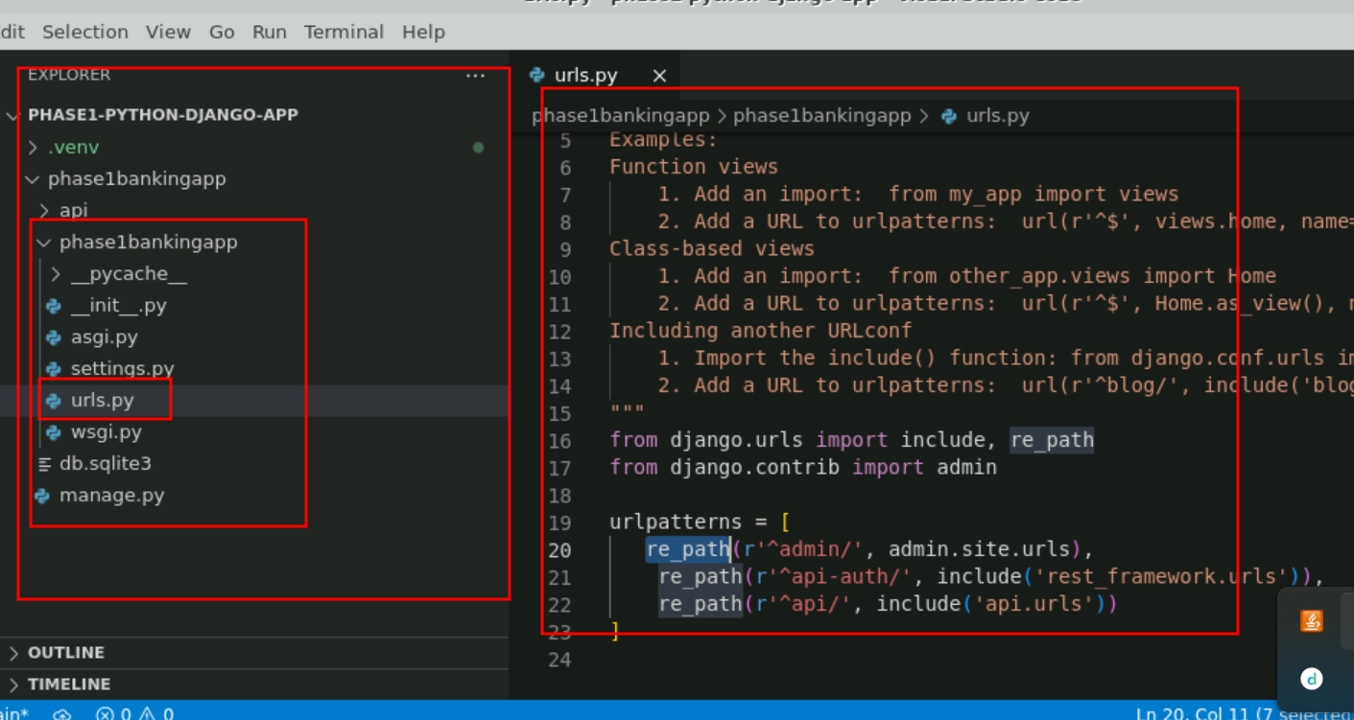

**Note** : Please refer phase1 project for all the python code.

* 1. Run the below commands to migrate models to the database   
     **python manage.py makemigrations**

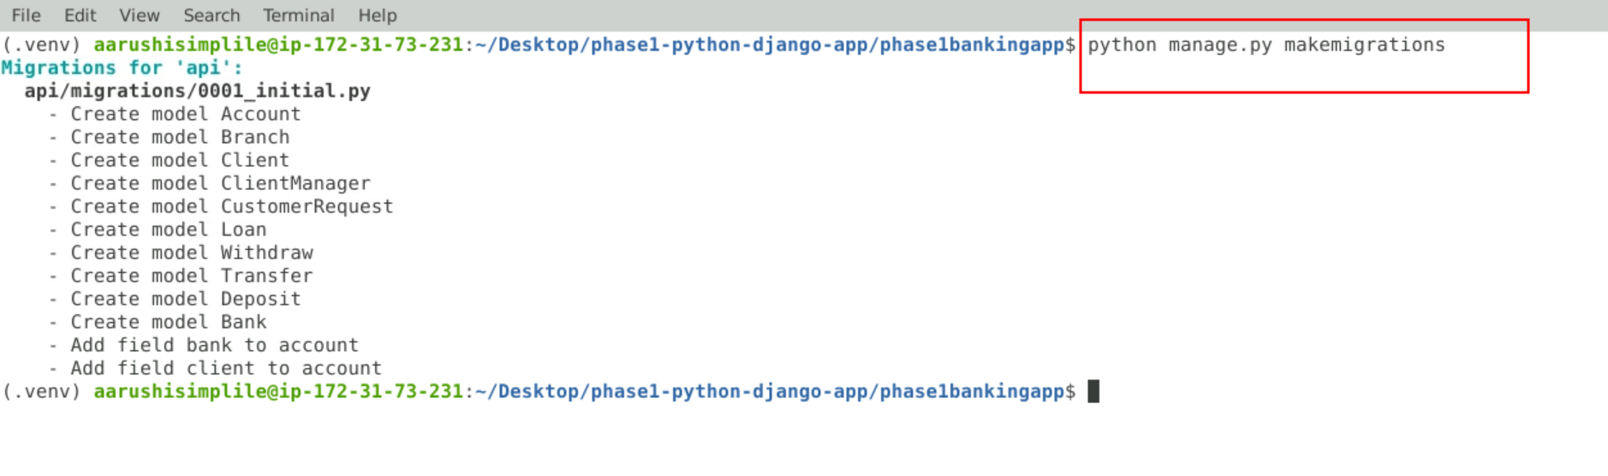

**python manage.py migrate**

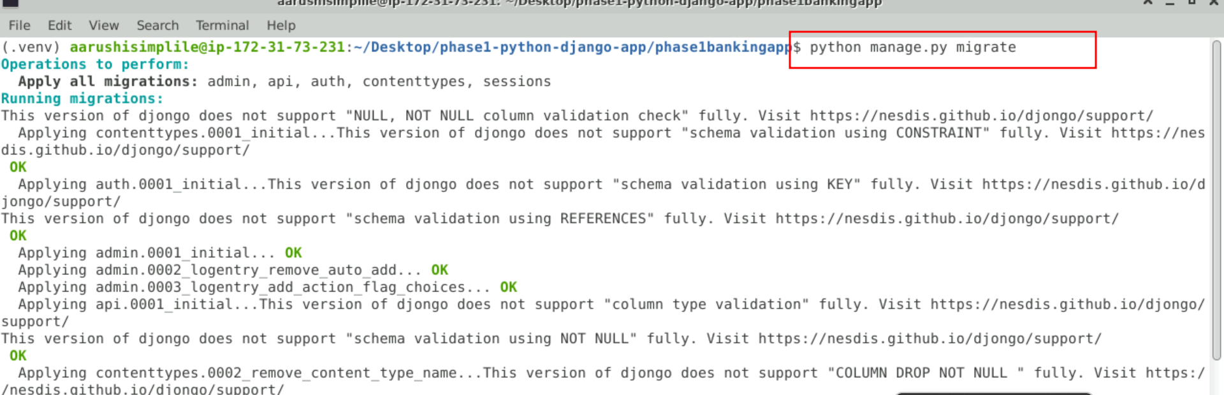

* 1. Check Mongo shell for the collections created mapping with the models

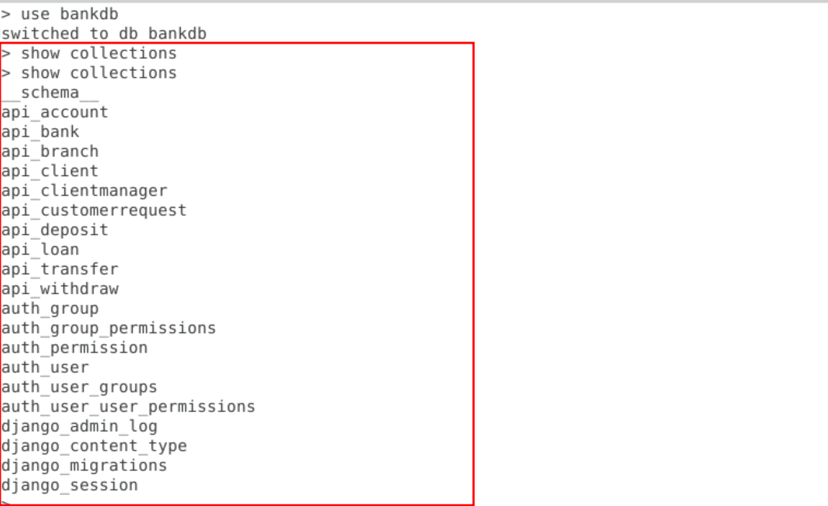

* 1. See the output on the browser as follows:

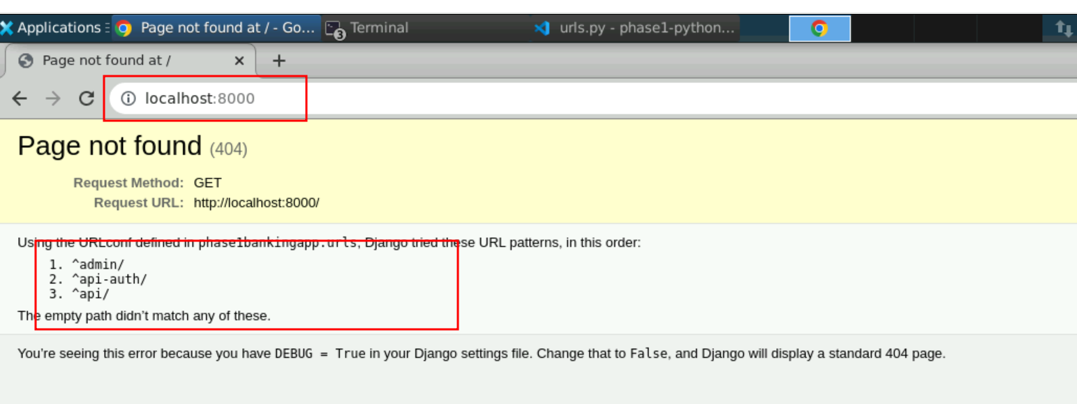

* 1. Now we will create the admin account. Django provided by default admin account which help to create the admin related task.

We need to enable the superuser user

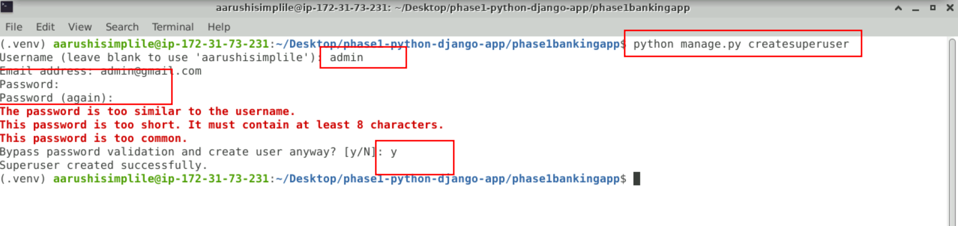

* 1. now once again run the application using below command as

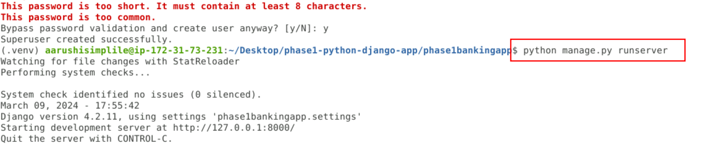

3.16: now open the below URL on browser.

<http://localhost:8000/admin>

the below page open

username is : admin and password is : admin

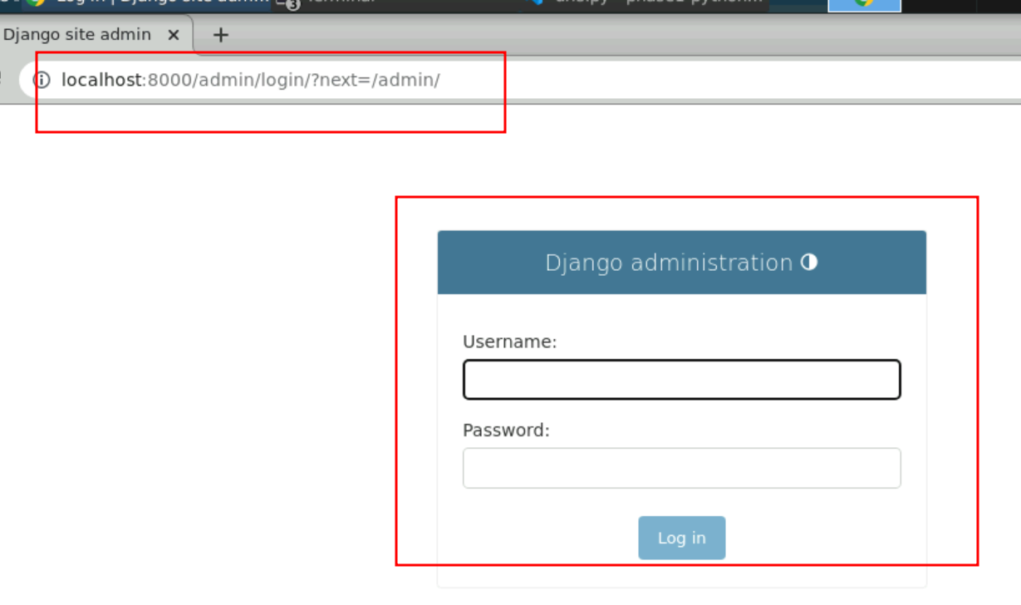

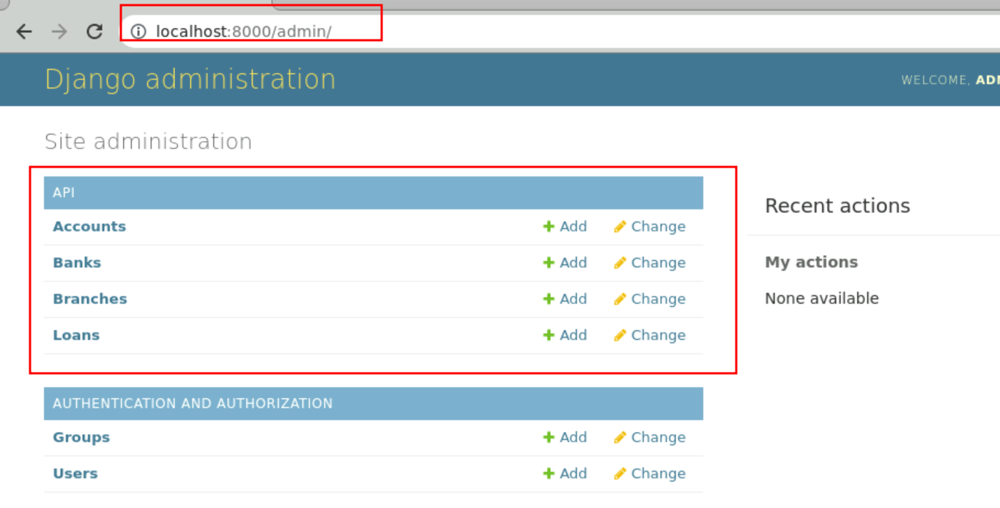

3.18 Now admin add the branches and bank details using GUI base provide by Python Django

Adding branches

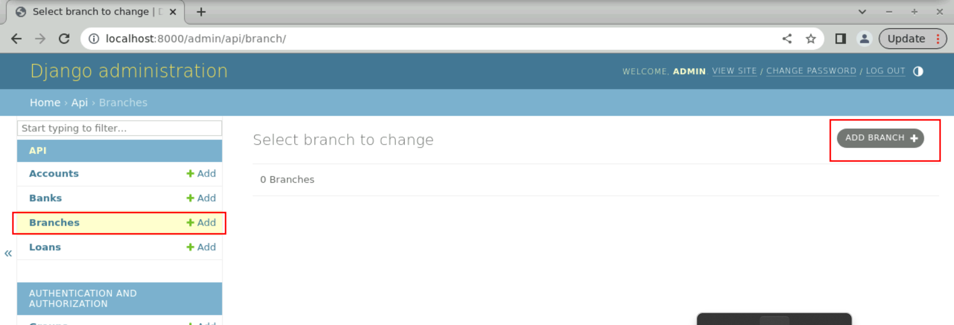

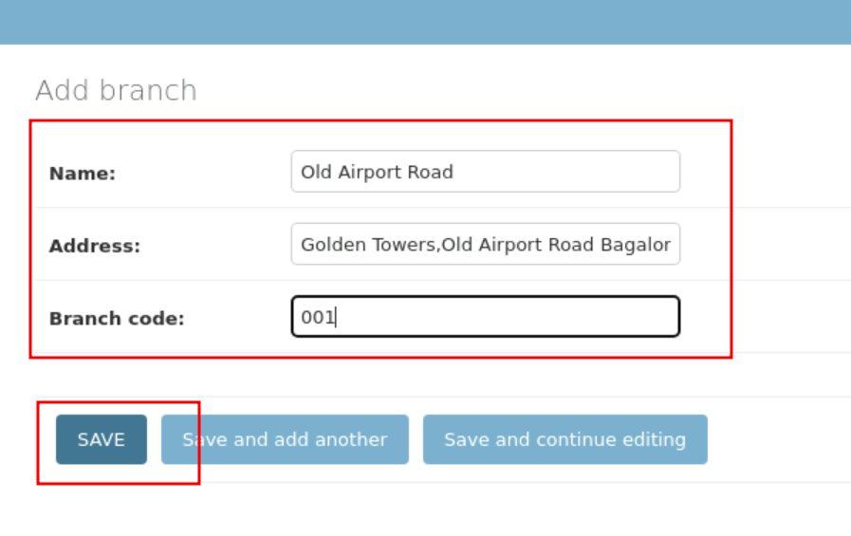

After added few branches

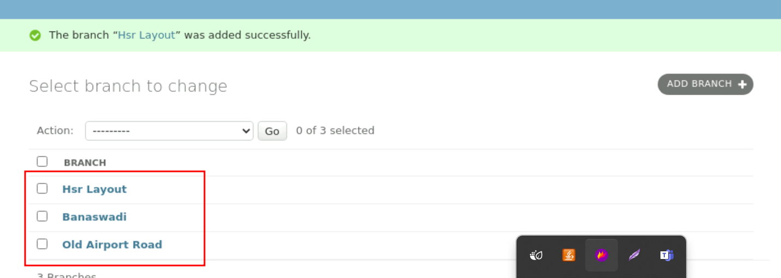

Now we will add the banks

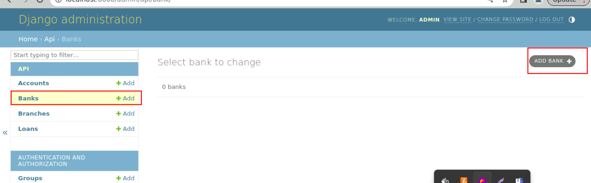

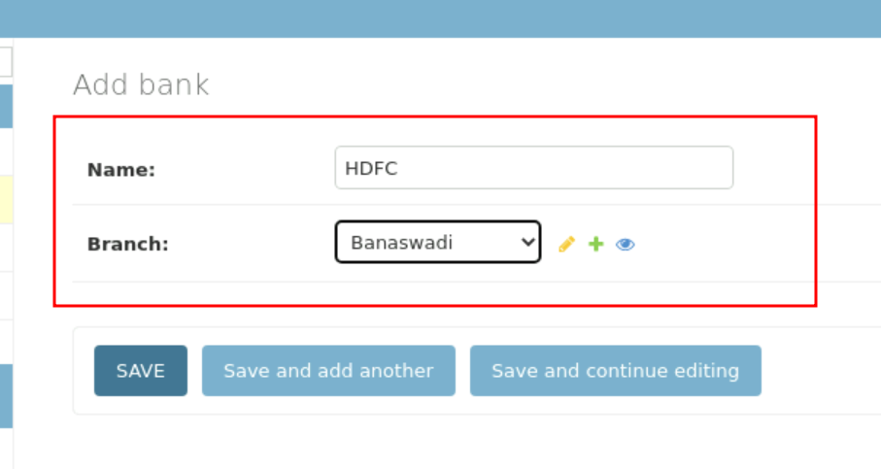

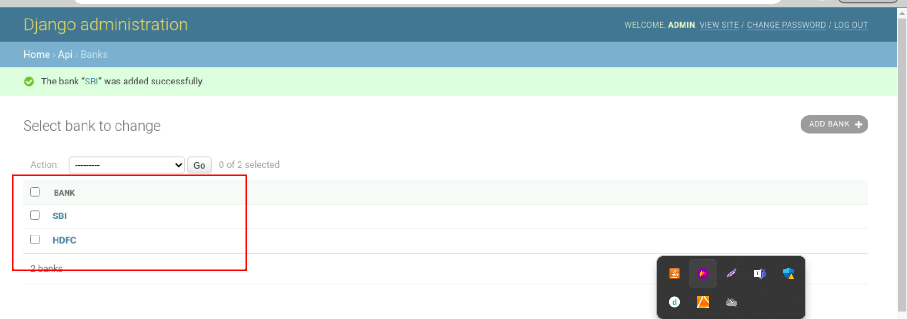

**Step 4: Executing the projects and testing in POSTMAN or any Browser Supported Rest Client Plugins**

1. Open the Rest Client Plugins
2. View all Branches details

**Method : Get**

**URL as** <http://localhost:8000/api/branches>

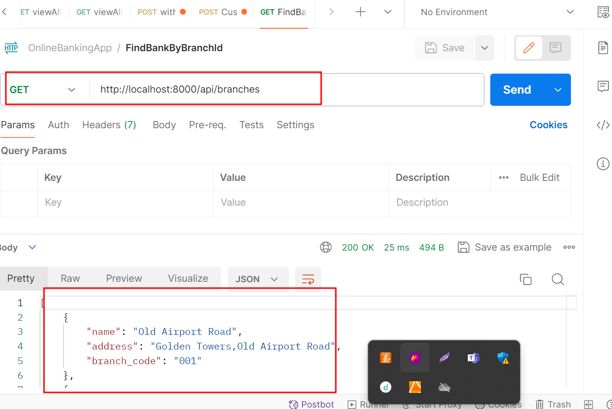

1. View all Bank details

**Method : Get**

**URL as** <http://localhost:8000/api/banks>

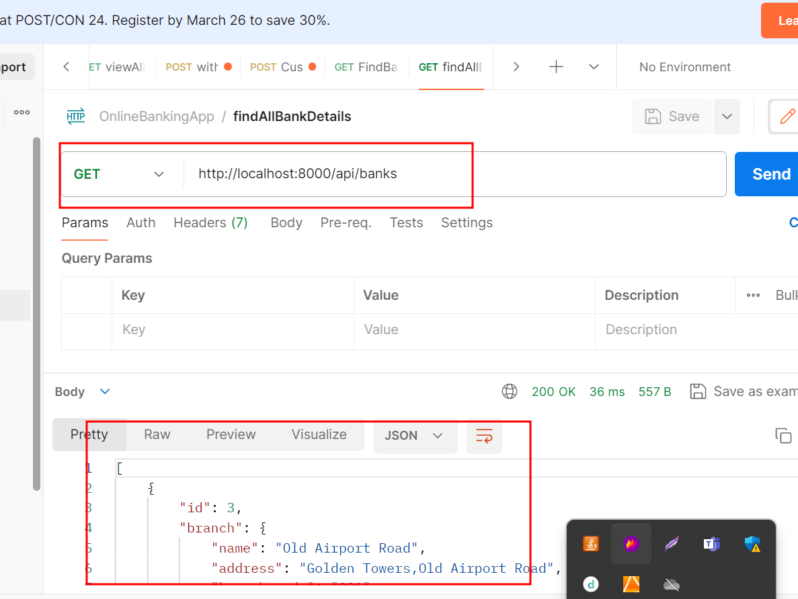

1. Create account

**Method : Post**

**URL as** <http://localhost:8000/api/create_account/>

**Header you need to set the option**

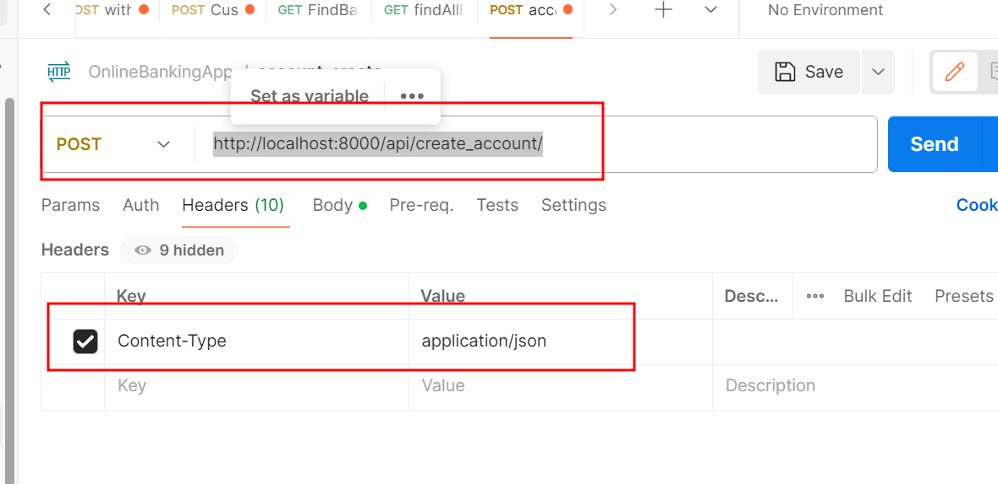

**In Body you need to pass the data**

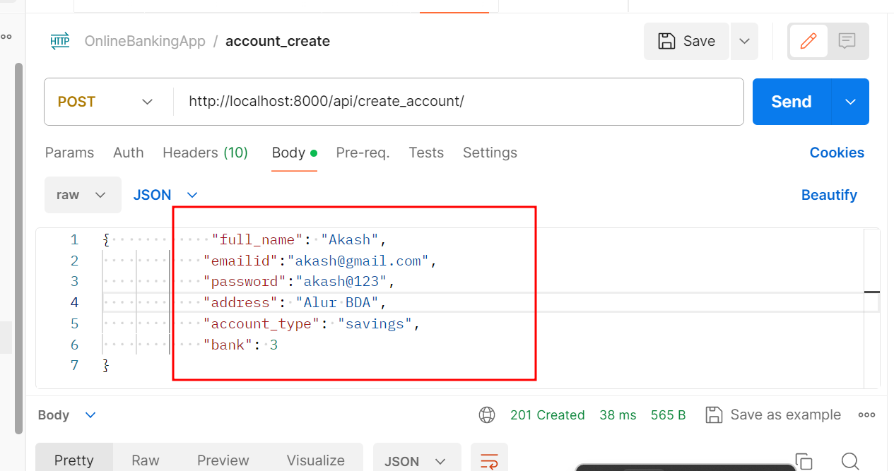

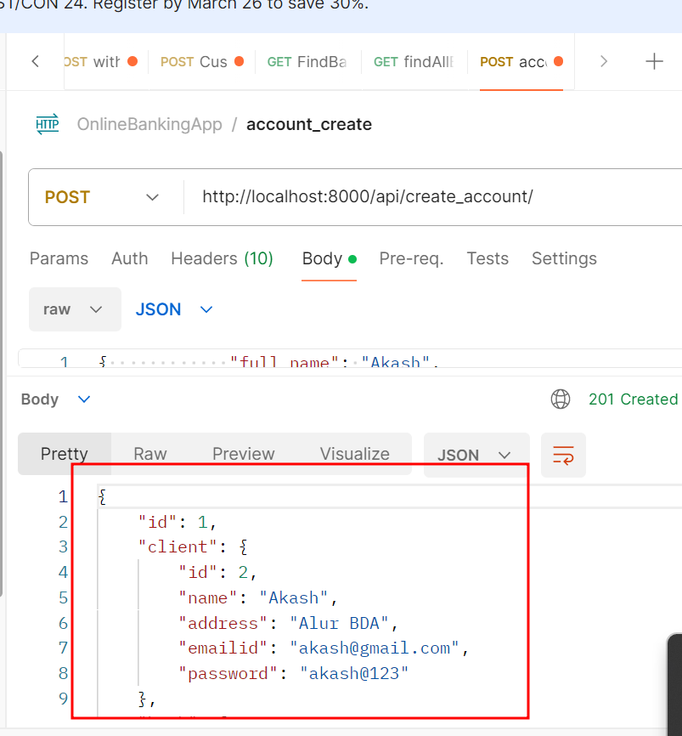

1. Find all account details

**Method : Get**

**URL as** <http://localhost:8000/api/accounts>

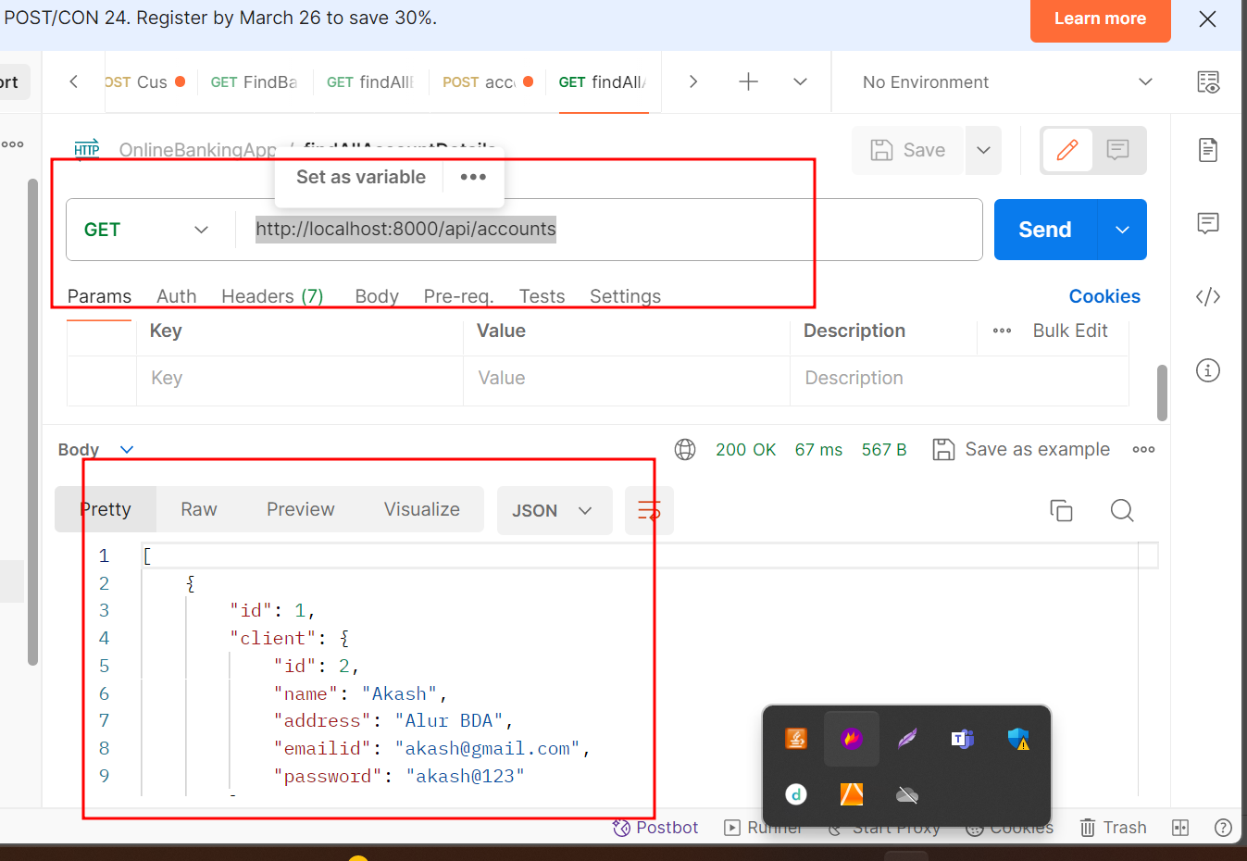

**4.6 Deposit the amount the account**

Method : Post

Header Content type : application/json

URL : <http://127.0.0.1:8000/api/deposits/>

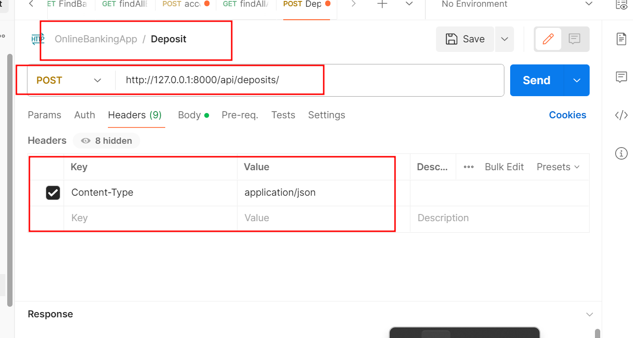

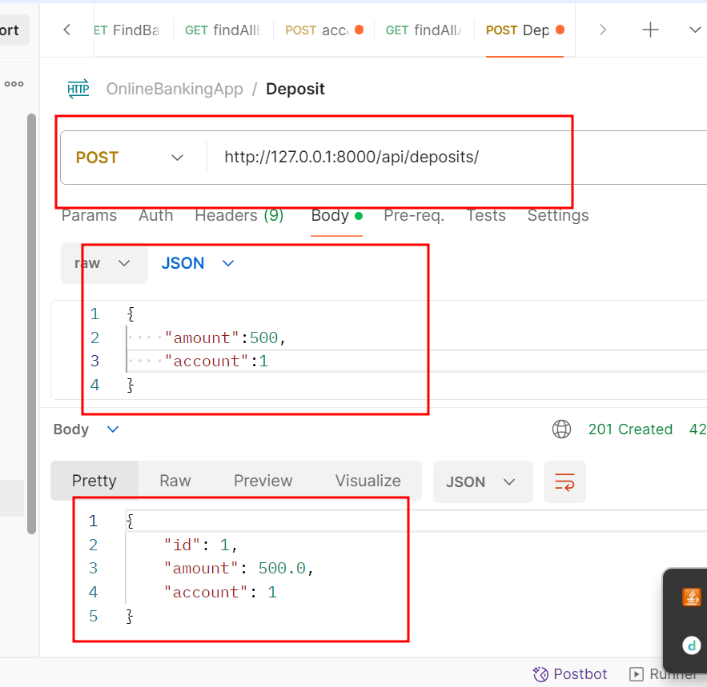

**4.7 : Withdrawn amount**

Method : Post

Header Content type : application/json

**URL :** <http://127.0.0.1:8000/api/withdrawals/>

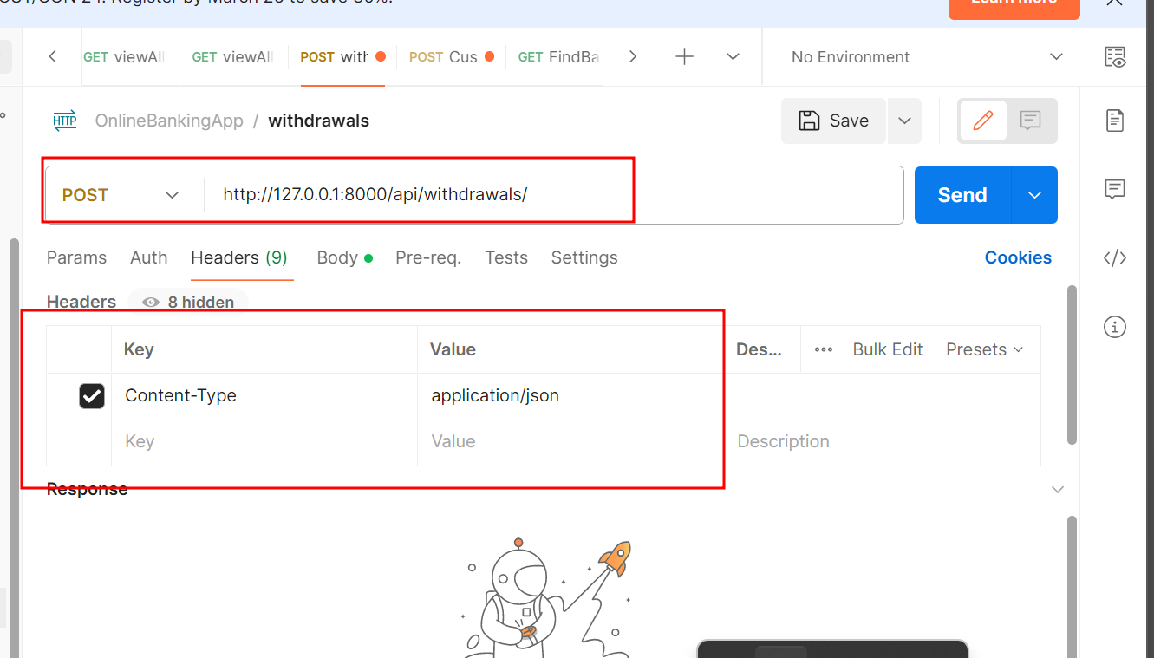

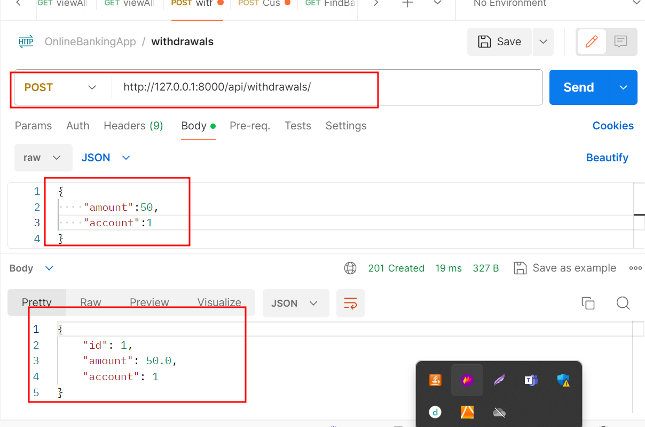

**4.8 : View all customer deposit info**

Method : Get

**URL :** <http://127.0.0.1:8000/api/deposits>

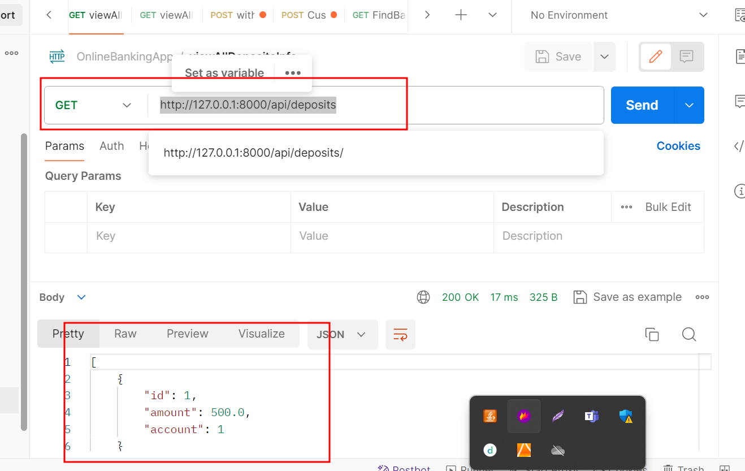

**4.8 : View all customer withdrawn info**

Method : Get

**URL :** <http://127.0.0.1:8000/api/withdrawals/>

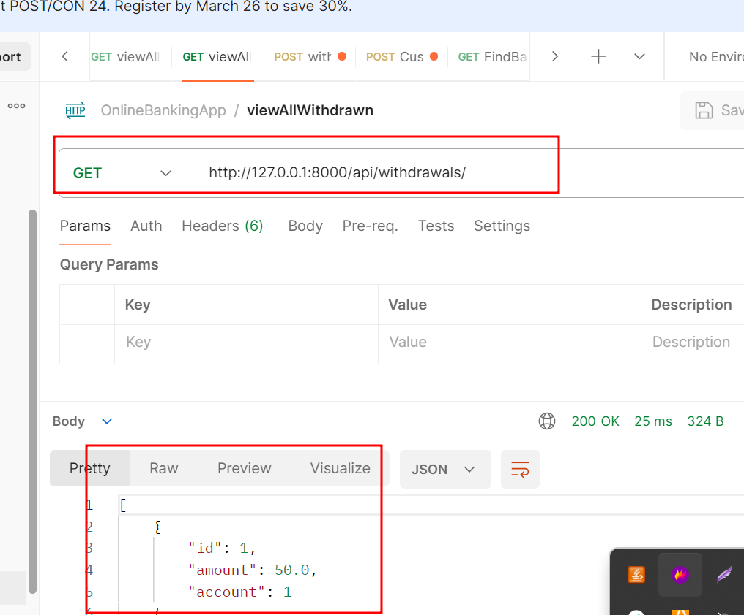

**4.9 : View transfer amount**

Method : Post

**URL :** <http://127.0.0.1:8000/api/transfer_amount/>

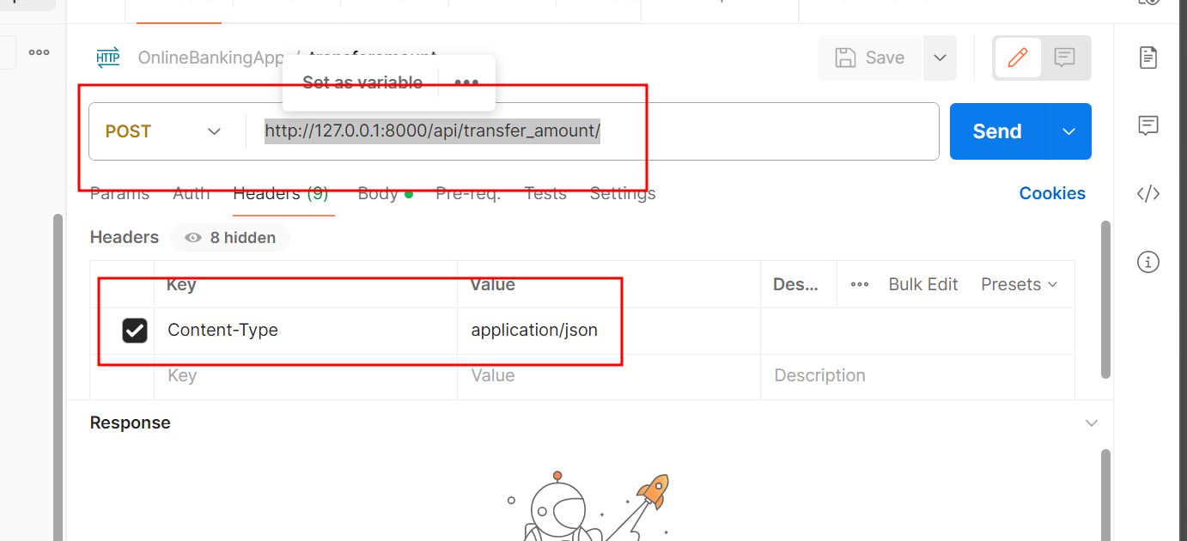

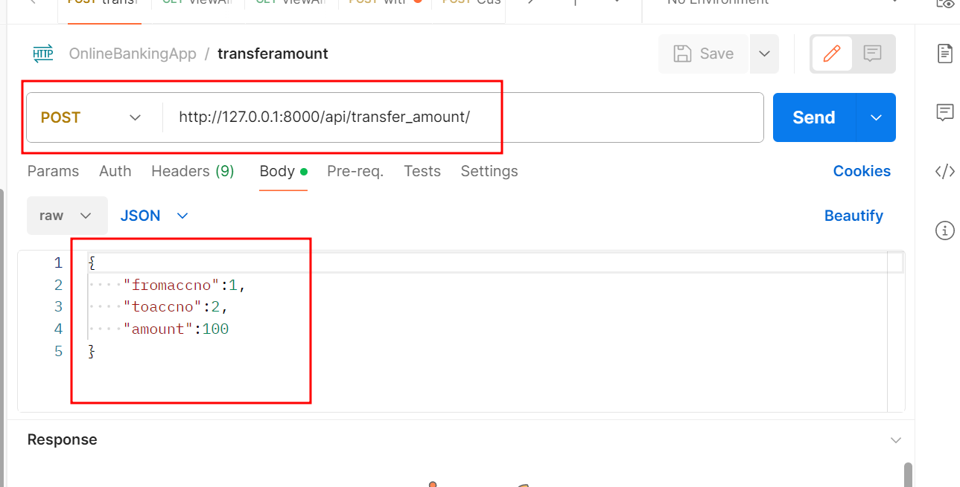

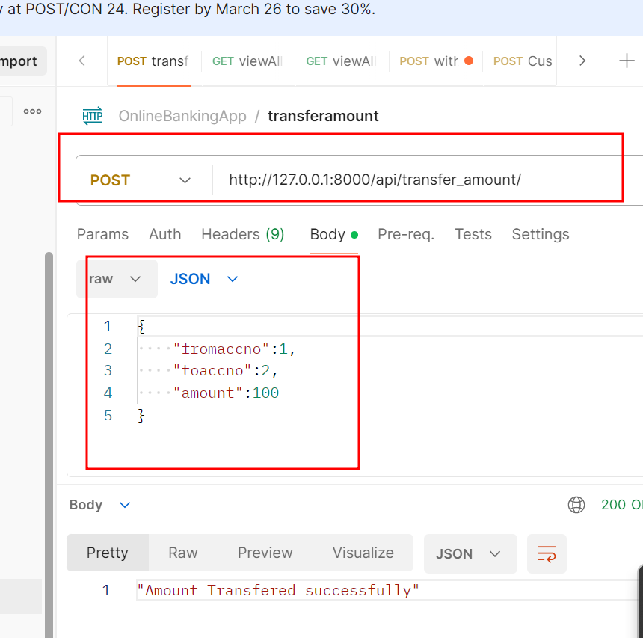

**5.0 : Customer request for different type of service**

Method : POST

**URL :** <http://127.0.0.1:8000/api/customer_request/>

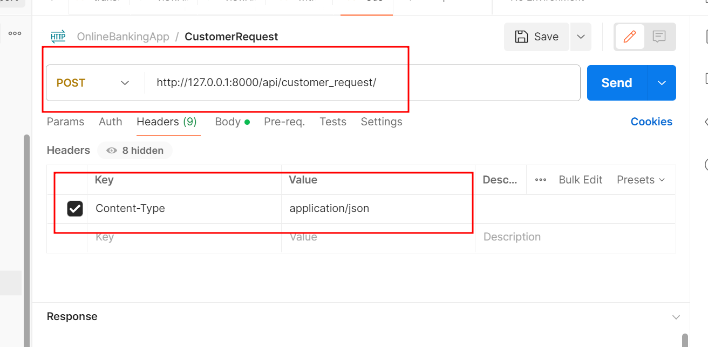

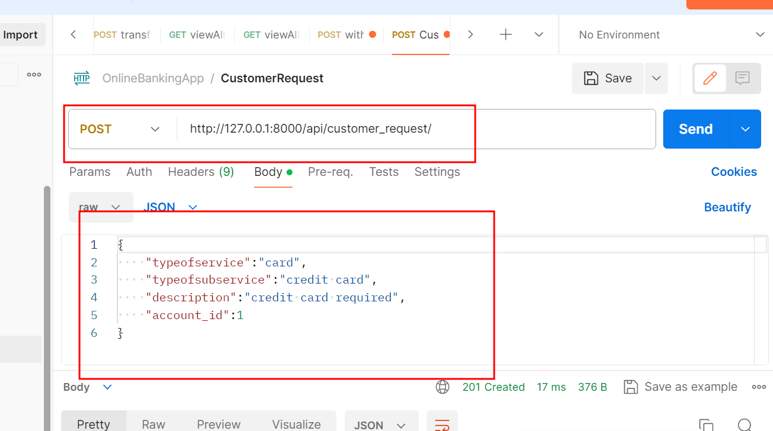

**5.1 : View all customer request**

Method : GET

**URL:** <http://127.0.0.1:8000/api/customer_request/>

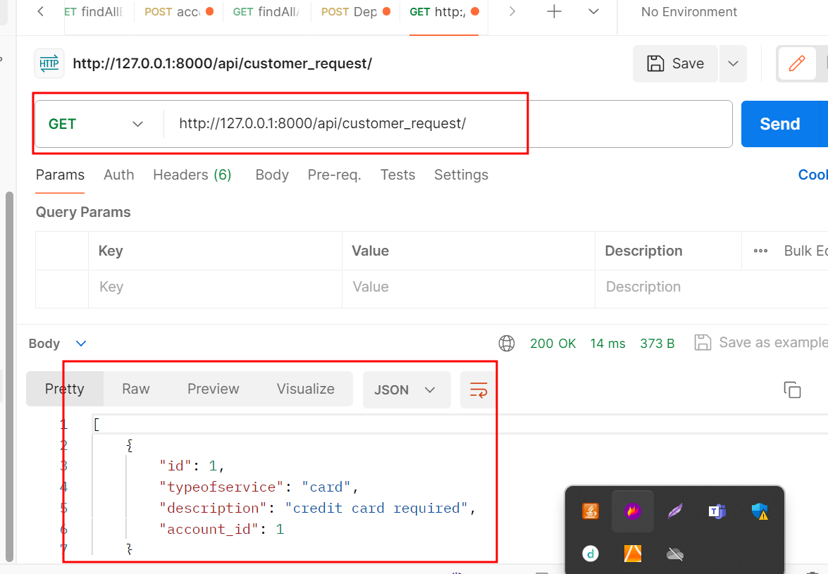

**5.2 : Sign after account created**

Method : POST

**URL:** <http://127.0.0.1:8000/api/signin_account/>

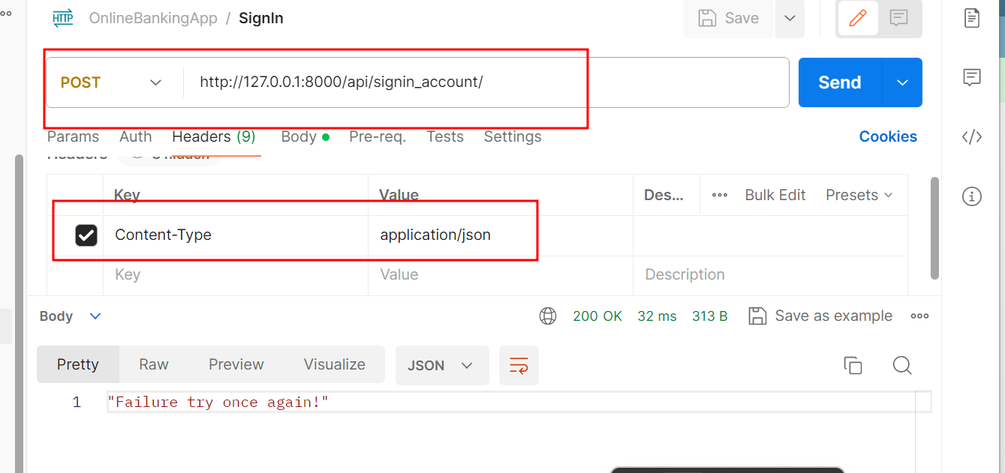

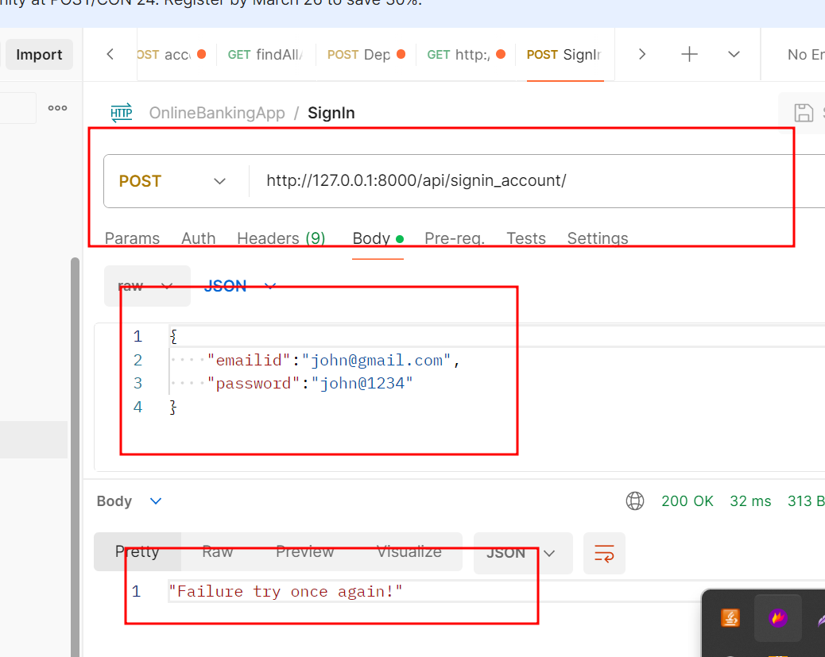

**With success message**

